6. 5G NR Frame Structure Analysis with Different Subcarrier Spacing
Objective:
1. To analyze the 5G NR frame structure by studying the effect of different subcarrier spacings,slot durations, and OFDM symbols using MATLAB.
Matlab Code:
clc;
clear;
close all;
scs = [15 30 60 120 240]; % Subcarrier Spacing (kHz)
mu = 0:4; % Numerology Index
bar(scs)
grid on
set(gca,'XTick',1:5)
set(gca,'XTickLabel',mu)
xlabel('Numerology Index (\mu)')
ylabel('Subcarrier Spacing (kHz)')
title('5G NR Subcarrier Spacing for Different Numerologies')
OUTPUT: on 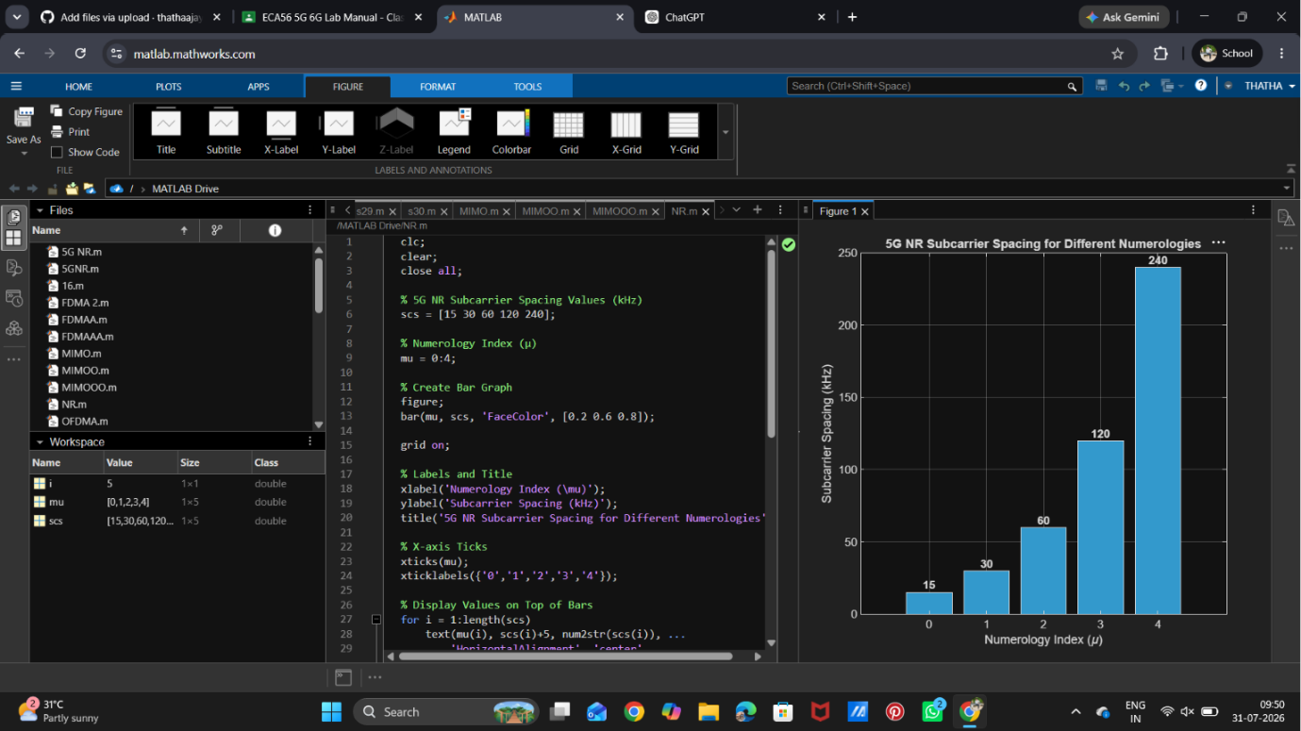

Objective 2:
Analyze the variation in slot duration corresponding to different 5G NR subcarrier spacing values using MATLAB. Compare the inverse relationship between subcarrier spacing and slot durationto understand how flexible numerology enables low-latency communication in 5G networks.
Objective 2 Matlab Code:
clear;
close all;
scs = [15 30 60 120 240]; % Subcarrier Spacing (kHz)
slot = [1 0.5 0.25 0.125 0.0625]; % Slot Duration (ms)
plot(scs, slot, 'o-', 'LineWidth', 2)
grid on
xlabel('Subcarrier Spacing (kHz)')
ylabel('Slot Duration (ms)')
title('5G NR Slot Duration for Different Subcarrier Spacing')
OUTPUT:
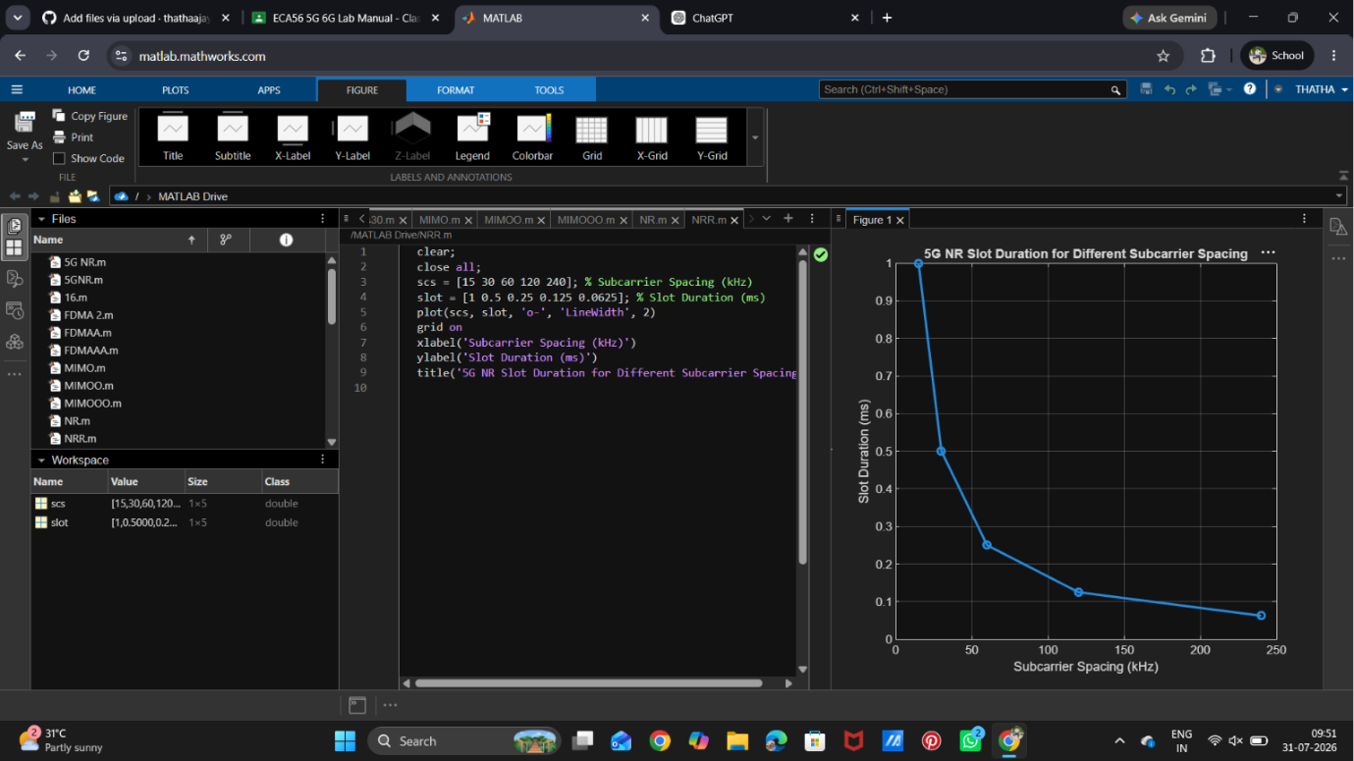

Objective:
3. Analyze the number of OFDM symbols present in a 5G NR slot for different numerology configurations using MATLAB. Observe that, under the normal cyclic prefix, each slot consistently contains 14 OFDM symbols irrespective of the subcarrier spacing.
Objective 3 Matlab Code:
clc;
clear;
close all;
scs = [15 30 60 120 240]; % Subcarrier Spacing (kHz)
symbols = [14 14 14 14 14]; % OFDM Symbols per Slot
figure
bar(scs, symbols)
grid on
xlabel('Subcarrier Spacing (kHz)')
ylabel('Number of OFDM Symbols')
title('OFDM Symbols per Slot for Different Subcarrier Spacing')
ylim([0 16])

OUTPUT:
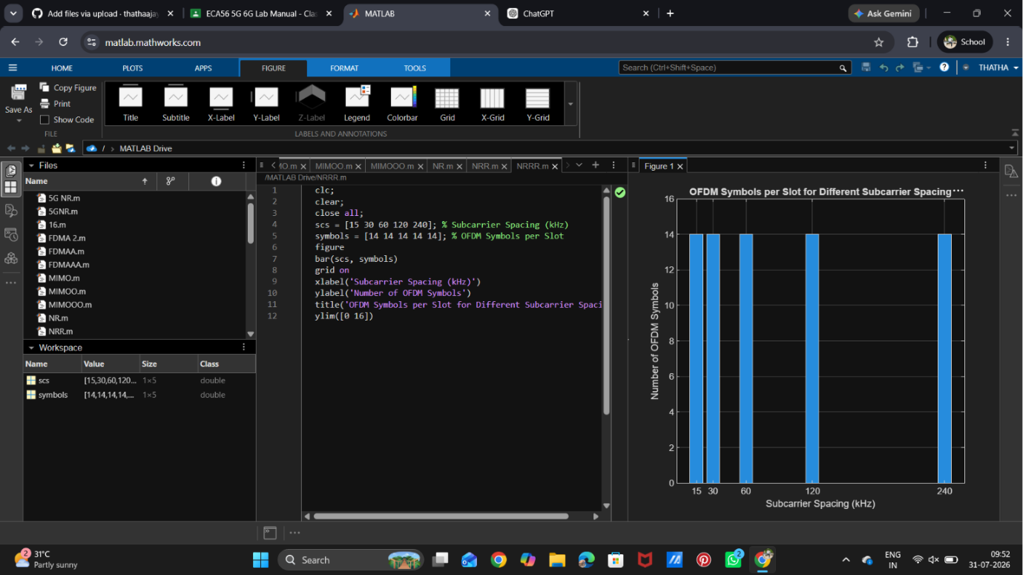

RESULT: The MATLAB analysis successfully demonstrated the flexible numerology of 5G NR. The results showed that increasing the subcarrier spacing decreases the slot duration while maintaining aconstant number of OFDM symbols per slot under the normal cyclic prefix configuration.

